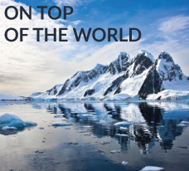

**BLOG 1  
On Top of the World**

**http://bit.ly/2lEGgX5**

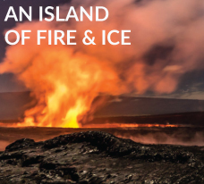

**BLOG 3**

**An Island of Fire & Ice**

**http://bit.ly/2lxMLuW**

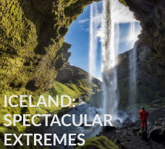

**BLOG 2  
Iceland: Spectacular Extremes**

**http://bit.ly/2jXO6L2**

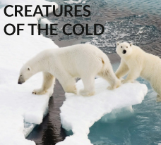

**BLOG 4  
Creatures of the Cold**

**http://bit.ly/2kuGpMB**